A

TECHNICAL SEMINAR REPORT

ON

**SMART DUST**

Submitted in partial of the requirements for the award of the degree of

### BACHELOR OF TECHNOLOGY

SPECIALIZATION IN

### ELECTRONICS AND COMMUNICATION ENGINEERING

Submitted by

**PRASANTH PHILIP KATTA 18P71A0450**

### SEMINAR COORDINATOR

Mr. A. Ganesh

(Assistant Professor)





**CERTIFICATE**

This is to certify that the Technical seminar report entitled “SMART DUST” is a bonafide record of work carried out by PRASANTH PHILIP KATTA (18P71A0450) under the guidance and supervision in partial fulfillment of the requirement for the award of Bachelor of Technology in Electronics and Communications engineering of Jawaharlal Nehru Technological University Hyderabad .During the year 2020-2021.

#### Mr. A. Ganesh (Seminar Coordinator)

ABSTRACT

Advances in hardware technology have enabled very compact, autonomous and mobile nodes each having one or more sensors, computation and communication capabilities, and a power supply. The Smart Dust project is exploring whether an autonomous sensing, computing, and communication system can be packed into a cubic millimeter mote to form the basis of integrated massively distributed sensor networks. It focuses on reduction of power consumption, size and cost. To build these small sensors, processors, communication devices, and power supply, designers have used the MEMS (Micro electro mechanical Systems) technology.

Smart Dust nodes otherwise known as “motes” are usually of the Size of a grain of sand and each mote consists of:

1. Sensors
2. Transmitter &receiver enabling bidirectional wireless communication.
3. Processor sand control circuitry
4. Power supply unit

Using smart dust nodes, the energy to acquire and process a sample and then transmit some data about it could be as small as a few nano Joules. These dust motes enable a lot of applications, because at these small dimensions, these motes can be scattered from aircraft for battle field monitoring or can be stirred into house paint to create the ultimate home sensor network.

TABLE OF CONTENTS

CHAPTER NO. TITLE PAGE NO

|  |  |  |
| --- | --- | --- |
| 1 | ABSTRACT | iii |
| 2 | LIST OF FIGURES | v |
| 3 | LIST OF SYMBOLS | vi |
| 4 | INTRODUCTION | 1 |
| 5. | THE MEMS TECHNOLOGY IN SMART DUST | 2 |
| 6. | SMART DUST TECHNOLOGY | 5 |
| 7. | OPERATION OF THE MOTE | 6 |
| 8. | COMMUNICATING WITH SMART DUST | 8 |
| 9. | OPTICAL COMMUNICATION | 10 |

1. ACTIVE OPTICAL TRANSMITTERS 14
2. LISTENING TO A DUST FIELD 15
3. CORE FUNCTIONALITY SPECIFICATION 17
4. MAJOR CHALLENGES 22
5. APPLICATIONS 23
6. HOW GAR THEY HAVE BEEN IMPLEMENTED 24
7. SUMMARY 25
8. REFRENCE 26

LIST OF FIGURES

|  |  |  |
| --- | --- | --- |
| SI NO | IMAGES | PAGE NO |
| 2 | STRUCTURAL COMPONENTS OF THE SMART DUST MOTE | 4 |
| 6 | ACTIVE STERED LASER | 12 |
| 7 | FREE SPACE OPTICAL NETWORK | 13 |
| 9 | IMAGING RECEIVER | 16 |
| 10 | TOP LEVEL DIAGRAM OF THE MOTE AND ARCITECTURE | 18 |
| 10 | TIMER AND ASSOCIATED MEMORIES | 19 |
| 10 | FUNCTIONAL BLOCKS | 20 |

List of Symbols, Abbreviations and Nomenclature

SI. NO. ITEM DEFINITION

|  |  |  |
| --- | --- | --- |
| 1 | MEMS | Micro-Electo-Mechanical Systems |
| 2 | IC | Integrated Circuit |
| 3 | SRAM | Static Random Acess Memory |
| 4 | CCR | Corner Cube Retroreflector |
| 5 | SDMA | Space Division Multiple Acess |
| 6 | CDMA | Code division Multiple Acess |

## INTRODUCTION

The current ultramodern technologies are focusing on automation and miniaturization. The decreasing computing device size, increased connectivity and enhanced interaction with the physical world have characterized computing's history. Recently, the popularity of small computing devices, such as hand held computers and cell phones; rapidly flourishing internet group and the diminishing size and cost of sensors and especially transistors have accelerated these strengths. The emergence of small computing elements, with sporadic connectivity and increased interaction with the environment, provides enriched opportunities to reshape interactions between people and computers and spur ubiquitous computing researches.

Smart dust is a tiny dust size device with extra-ordinary capabilities. Smart dust combines sensing, computing, wireless communication capabilities and autonomous power supply within volume of only few millimeters and that too at low cost. These devices are proposed to be so small and light in weight that they can remain suspended in the environment like an ordinary dust particle. These properties of Smart Dust will render it useful in monitoring real world phenomenon without disturbing the original process to an observable extends. Presently the achievable size of Smart Dust is about 5mm cube, but we hope that it will eventually be as small as a speck of dust. Individual sensors of smart dust are often referred to as motes because of their small size. These devices are also known as MEMS, which stands for *micro electro-mechanical sensors*.

## THE MEMS TECHNOLOGY IN SMART DUST

Smart dust requires mainly revolutionary advances in miniaturization, integration and energy management. Hence designers haves used MEMS technology to build small sensors, optical communication components and power supplies. Micro electro- mechanical systems consist of extremely tiny mechanical elements, often integrated together with electronic circuitory. They are measured of micrometers, that is, millions of a meter. They are made in a similar fashion as computer chips. The advantage of this manufacturing process is not simply that a small structure can be achieved but also that thousands or even millions of system elements can be fabricated simultaneously. This allows systems to be both highly complex and extremely low- cost

Micro-Electro-Mechanical Systems (MEMS) is the integration of mechanical elements, sensors, actuators and electronics on a common silicon substrate through micro fabrication technology. While the electronics are fabricated using integrated circuit (IC) process sequences (e.g. CMOS, Bipolar processes) the micromechanical components are fabricated using compatible “micromachining” processes that selectively etch away parts of the silicon wafer or add new structural layers to form the mechanical and electromechanical devices. MEMS realizes a complete system on chip technology.

Microelectronic integrated circuits can be thought of as the “brains” of a system and allows Microsystems to sense and control the environment. Sensors gather information from the environment through measuring mechanical, thermal, biological, chemical, optical and magnetic phenomena. The electronics then process the information derived from the sensors and through some decision making capability direct the actuators to respond by moving, positioning, regulating, and filtering, thereby controlling the environment for some desired purpose. Because MEMS devices are manufactured using batch fabrication techniques similar to those use for integrated circuits, unprecedented levels of functionality, reliability, add sophistication can be placed on a small silicon chip relatively low cost. The deep insight of MEMS is as a new

manufacturing technology, a way of making complex electromechanical systems using batch fabrication techniques similar to those used for integrated circuits, and uniting these electromechanical elements together with electronics. Historically, sensors and actuators are the most costly and unreliable parts of a sensor-actuator-electronics systems. MEMS technology allows a these complex electromechanical systems to be manufactured using batch fabrication techniques, increasing the reliability of the sensors and actuators to equal that of integrated circuits. The performance of MEMS devices and systems is expected to be a superior to macro scale components and systems, the price is predicted to be much lower.

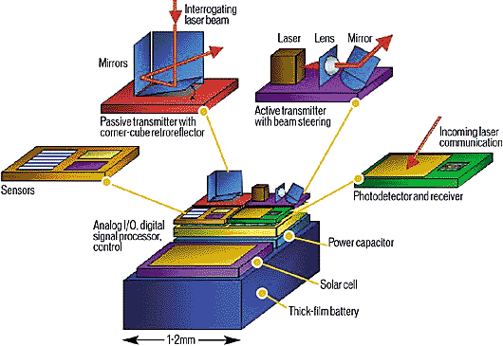

*Figure 1: Structural Components of the Smart Dust Mote*

## SMART DUST TECHNOLOGY

Integrated into a single package are:-

* 1. MEMS sensors
  2. MEMS beam steering mirror for active optical transmission
  3. MEMS corner cube retroreflector for passive optical transmission
  4. An optical receiver
  5. Signal processing and control circuitory
  6. A power source based on thick film batteries and solar cells

This remarkable package has the ability to sense and communicate and is self powered. A major challenge is to incorporate all theses functions while maintaining very low power consumption.

* + - Sensors collect information from the environment such as light, sound,

temperature, chemical composition etc

* + - Smart dust employs 2 types of transmission schemes: passive transmission using corner cube retroreflector to transmit to base station and active

transmission using a laser diode and steerable mirrors for mote to mote communication.

* + - The photo diode allows optical data reception.
    - Signal processing and control circuitory consists of analog I/O, DSPs to control and process the incoming data
    - The power system consists of a thick film battery, a solar cell with a charge integrating capacitor for a period of darkness.

## OPERATION OF THE MOTE

The Smart dust mote is run by a micro controller that is not only determines the tasks performed by the mote, but controls power to the various components of the system to conserve energy. Periodically the microcontroller gets a reading from one of the sensors, which measure one of a number of physical or chemical stimuli such as temperature, ambient light, vibration, acceleration, or air pressure, processes the data and stores it in memory. It also occasionally turns on the optical receiver to see if anyone is trying to communicate wit it. This communication may include new programs or messages from other motes. In response to a message or upon its own initiative the microcontroller will use the corner cube retroreflector or laser to transmit sensor data or a message to the base station or another mote.

The primary constraint in the design of the Smart Dust motes is volume, which in turn puts a severe constrain on energy since we do not have much room for batteries or large solar cells. Thus, the motes must operate efficiently and conserve energy whenever possible. Most of the time, the majority of the mote is powered off with only a clock and few timers running. When a timer expires, it powers up a part of the mote to carry out a job, then powers off. A few of the timers control the sensors that measure one of the many physical or chemical stimuli such as temperature, ambient light, vibration, acceleration, or air pressure. When one of these timers expires, it powers up the corresponding sensors, take a sample, and converts in to a digital word. If the data is interesting, it may either be stored directly in the SRAM or the microcontroller is powered up to perform more complex operations with it. When this task is complete, everything is again powered down and the timer begins counting again.

Another timer controls the receiver. When that timer expires, the receiver powers up and look for an incoming packet. If it doesn’t see one after a certain length of time, it is powered down again. The mote can receive several types of packets, including ones that are new program code that is stored in the program memory. This allows the user to change the behavior of the remotely. Packets may also include messages from the base

station or other motes. When one of these is received, the micro controller is powered up and is used to interpret the contents of the message. The message may tell the mote to do something in particular, or it may be a message that is just being passed from one mote to another on its way to a particular destination. In response to a message or to another timer expiring, the microcontroller will assemble a packet containing a sensor data or a message and transmit it using either the corner cube retroreflector or the laser diode, depending on which it has. The laser diode contains the onboard laser which sends signals to base station by blinking on and off. The corner cube retroreflector transmits information just by moving a mirror and this changing the reflection of a laser beam from the base station.

This technique is substantially more energy efficient than actually generation radiation. With the laser diode and a set of beam scanning mirrors, we can transmit data in any direction desired, allowing the mote to communicate with other Smart dust motes.

## COMMUNICATING WITH A SMART DUST

COMMUNICATING FROM A GRAIN OF SAND

Smart Dust’s full potential can only be attained when the sensor nodes communicate with one another or with a central base station. Wireless communication facilities simultaneous data collection from thousands of sensors. There are several options for communicating to and from a cubic millimeter computer.

Radio-frequency and optical communications each have their strengths and weakness. Radio-frequency communication is well understood, but currently requires minimum power levels in the multiple milliwatt range due to analog mixers, filters, and oscillators. If the whisker-thin antennas of centimeter length can be accepted as a part of a dust mote, then reasonably efficient antennas can be made for radio-frequency communication. While the smallest complete radios are still on the order of a few hundred cubic millimeters, there is active work in the industry to produce cubic millimeter radios.

Moreover RF techniques cannot be used because of the following disadvantages:

1. Dust motes offer limited space for antennas, thereby demanding extremely short wavelength (high frequency transmission). Communication in this regime is not currently compatible with low power operation of the smart dust.
2. Furthermore radio transceivers are relatively complex circuits making it difficult to reduce their power consumption to required microwatt levels.
3. They require modulation, band pass filtering and demodulation circuitory.

So an attractive alternative is to employ free space optical transmission. Studies have shown when a line of sight path is available, well defined free space optical links require significantly lower energy per bit than their RF counterparts.

There are several reasons for power advantage of optical links:

1. Optical transceivers require only a simple base band analog and digital circuitory
2. No modulators, active band pass filters or demodulators are needed.
3. The short wavelength of visible or near infra red light (of the order of 1 micron) makes it possible for a millimeter scale device to emit a narrow beam (ie, high antenna gain can be achieved).

As another consequence of this short wavelength, a Base Station Transceiver (BTS) equipped with a compact imaging receiver can decode the simultaneous transmissions from a large number of dust motes from different locations within the receiver field of view, which is a form of space division multiplexing. Successful decoding of these simultaneous transmissions requires that dust motes not block one another’s line of sight to the BTS. Such blockage is unlikely in view of the dust mote’s small size.

Semiconductors lasers and diode receivers are intrinsically small, and the corresponding transmission and detection circuitory for on/off keyed optical communication is more amenable to low- power operation than most radio schema. Perhaps most important, optical power can be collimated in a tight beam even from small apertures. Diffraction enforces a fundamental limit on the divergence of a beam, whether it comes from an antenna or a lens. Laser pointers are cheap examples of milliradian collimation from a millimeter aperture. To get similar collimation for a 1-GHz radio-frequency signal would require an antenna 100 meters across, due to the difference in wavelength of the two transmissions. As a result, optical transmitters of millimeter size can get antenna gains of one million or more, while similarly sized radio-frequency antennas are doomed by physics to be mostly isotropic.

Collimated optical communicate on has two major drawbacks. Line of sight is required for all but the shortest distances, and narrow beans imply the need for accurate pointing. Of these, the pointing accuracy can be solved by MEMS technology and clever algorithms, but an optical transmitter under a leaf or a shirt pocket is little use to anyone. We have chosen to explore optical communication in some depth due to the potential for extreme low power consumption.

## OPTICAL COMMUNICATIONS

We have explored two approaches to optical communications: passive reflective systems and active steered laser systems. In a passive communication system, the dust mote does not require an onboard light source. Instead a special configuration of mirrors can either reflect or not reflect light to a remote source.

Passive reflective systems

The passive reflective communication is obtained by a special device called CCR (Corner Cube Retroreflector) consist of three mutually orthogonal mirrors. Light enters the CCR, bounces off each of the three mirrors, and is reflected back parallel to the direction it entered. In the MEMS version, the device has once mirror mounted on a spring at an angle slightly a skew from perpendicularity to the other mirrors. It is in this position, because the light entering the CCR does not return along the same path, little light returns to the source- a digital 0. Applying voltage between this mirror and an electrode beneath it causes the mirror to shift to a position perpendicular to other mirrors, thus causing the light entering CCR to return to its source- a digital 1. The mirrors low mass allows the CCR to switch between these two states up to a thousands times per second, using a less than a nano joule per 0→1 transition. A 1 →0 transition, on the other hand, is practically free because dumping the charge stored on the electrode to the ground requires almost no energy. Our latest Smart dust is a 63- mm3 autonomous bidirectional communication mote that receives an optical signal, generates a pseudorandom sequence based on this signal to emulate sensor data, and then optically transmits the result. The system contains a micromachined corner-cube reflector, a 0.078 mm3 CMOS chip that draws 17 microwatts, and a hearing aid battery. In addition to a battery based operation, we have also powered the device using a 2 mm2 solar cell. This mote demonstrates Smart dusts essential concepts, such as optical data transmission, data processing, energy management, miniaturization, and system integration.

A passive communication system suffers several limitations. Unable to communicate with each other, motes rely on a central station equipped with a light source to send and receive data from other motes. If a given mote does not have a clear line of sight to the central station, that mote will be isolated from the network. Also, because the CCR reflects only a small fraction of the light emitted from the base station, thus system’s range cannot easily extend beyond 1 kilometer. To circumvent these limitations, dust motes must be active and have their own onboard light source.

Active- steered laser systems

For mote to mote communication, an active steered laser communication system uses an onboard light source to send a tightly collimated light beam towards an intended receiver. Steered laser communication has the advantage of high power density; for example, a 1- milliwaat laser radiating into 1 milliradian (3.4 arc seconds) has a density of approximately 318 kilowatts per steradian (there are 4 П steradian in a sphere), as opposed to a 100-watt light bulb that radiates 8 watts per steradian isotropically. A Smart Dust mote’s, emitted beam would have a divergence of approximately 1 milliradian, permitting communication over enormous distances using milliwatt of power. Each mote must carefully weigh the needs to sense, compute, communicate, and evaluate its energy reserve status before allocating precious nanojoules of energy to turn on its transmitter or receiver. Because theses motes spend most of their time sleeping, with their receiver turned off, scheduling a common awake time across the network is difficult. If motes don’t wake up in a synchronized manner, a highly dynamic network topology and large packet latency results. Using burst mode communication, in which the laser operates at up to several tens of megabits per second for a few milliseconds, provides the most energy-efficient way to schedule this network. This procedure minimizes the mote’s duty cycle and better utilizes its energy reserves. The steered agile laser transmitter consists of a semiconductor diode laser coupled with a collimating lens and MEMS bean steering optics based on a two degree of freedom silicon micro mirror. This system integrates all optical components into an active 8 mm3 volume as the figure shows.

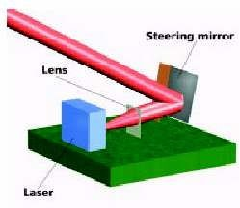

## CORNER CUBE RETROREFLECTOR

These MEMS structure makes it possible for dust motes to use passive optical transmission techniques i.e., to transmit modulated optical signals without supplying any optical power. It comprises of three mutually perpendicular mirrors of gold- coated polysilicon. The CCR has the property that any incident ray of light is reflected back to the source (provided that it is incident within a certain range of angles centered about the cube’s body diagonal). If one of the mirrors is misaligned, this retroreflector property is spoiled. The micro fabricated CCR contains an electrostatic actuator that can deflect one of the mirrors at kilohertz rate. It has been demonstrated that a CCR illumination by an external light source can transmit back a modulated signal at kilobits per second. Since the dust mote itself does not emit light, passive transmitter consumes little power. Using micro fabricated CCR, data transmission at a bit rate upto 1 kilobit per second and upto a range of 150 meters, using a 5 milliwatt illuminating a laser is possible.

It should be emphasized that CCR based passive optical links require an uninterrupted line of sight. The CCR based transmitter is highly directional. A CCR can transmit to the BTS only when the CCR body diagonal happens to point directly towards the BTS, within a few tens of degrees. A passive transmitter can be made more omni directional by employing several CCRs, oriented in different directions, at the expense of increased dust mote size.

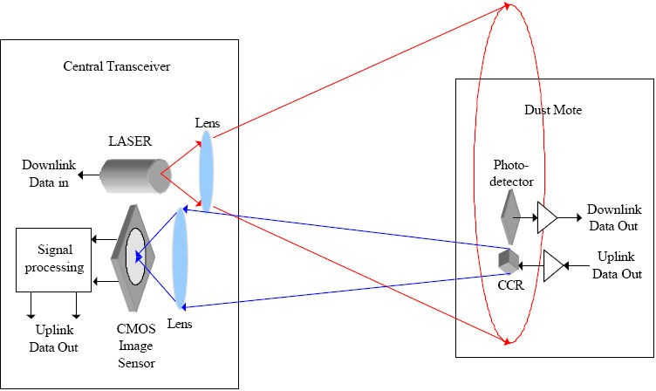

*Figure 2:Free Space Optical Network*

The figure illustrates free space optical network utilizing the CCR based passive uplink. The BTS contains a laser whose beam illuminates an area containing dust motes. This beam can be modulated with downlink data including commands to wake up and query the dust motes. When the illuminating beam is not modulated, the dust motes can use their CCRs to transmit uplink data back to the base station. A high frame rate CCD video camera at the BTS sees the CCR signals as lights blinking on and off. It decodes these blinking images to yield the uplink data. Analysis shows that this uplink scheme achieves several kilobits per second over hundreds of meters in full sunlight. At night, in clear, still air, the range should extend to several kilometers. Because the camera uses an imaging process to separate the simultaneous transmissions from the dust motes at different locations, we say it uses ‘space division multiplexing’. The ability for a video camera to resolve these transmissions is consequence of the short wavelength of visible or near infra red light. This does not require any coordination among the dust motes.

## ACTIVE OPTICAL TRANSMITTERS

When the application requires dust motes to use active optical transmitters, MEMS technology can be used to assemble a semiconductor laser, a collimating lens and a beam steering micro mirror. Active transmitters make possible peer to peer communication between dust motes, provided there exists a line of path of sight between them. Power consumption imposes a trade off between bandwidth and range. The dust motes can communicate over a long distances at low data rates or higher bit rates over shorter distances. The relatively higher power consumption of semiconductor lasers dictates that these active transmitters be used for short duration burst mode communication only. Sensor network using active dust mote transmitters will require some protocol for dust motes to aim their beam towards the receiving parties.

## LISTENING TO A DUST FIELD

Many Smart Dust applications rely on direct optical communication from an entire field of dust motes to one or more base stations. These base stations must therefore be able to receive volume of simultaneous optical transmissions. Further, communication must be possible outdoors in bright sunlight which has an intensity of approximately 1 kilowatt per square meter, although the dust motes each transmit information with a few milliwatts of power. Using a narrow- band optical filter to eliminate all sunlight expect the portion near the light frequency used for communication can partially solve this second problem, but the ambient optical power often remains much stronger than the received signal power.

Advantage of imaging receivers

As with the transmitter, the short wavelength of optical transmission compared with radio frequency overcomes both challenges. Light from a large field of view field can be focused into a image, as in our eye or camera. Imaging receivers utilize this to analyze different portions of the image separately to process simultaneous transmissions from different angles. This method of distinguishing transmissions based on their originating location is referred to as space division multiple access (SDMA). In contrast, most radio- frequency antennas receive all incident radio power in a single signal, which requires using additional tactics, such as frequency tuning or code division multiple access (CDMA), to separate simultaneous transmissions.

Imaging receivers also offer the advantage of dramatically decreasing the ratio of ambient optical power to received signal power. Ideally, the imaging receiver will focus all of the received power from a single transmission onto a single photo detector. If the receiver has an n n array pixels, then the ambient light that each pixel receives is reduced by a factor n2 compared with a non imaging receiver

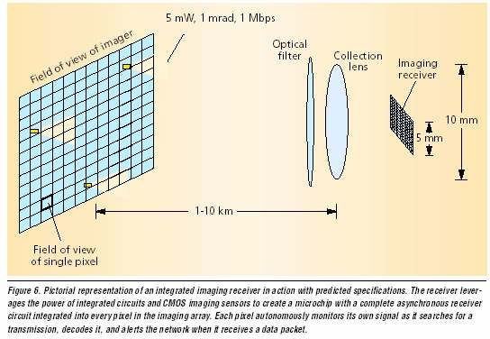

Video camera

A video camera is a straightforward implementation of an imaging receiver. If each member in a colony of Smart Dust motes flashes its own signal at a rate of a few bits per second, then each transmitter will appear in the video stream at a different location in the image. Using a high speed camera and a dedicated digital signal processor to process the video signal achieves higher date rates. With modern cameras and DSPs, processing video about 1000 frames per second should be feasible. This would allow communication at a few hundred bits per second, which is acceptable for many applications. Alternative receiver architecture provides a more elegant solution at much higher data rates, avoiding the need for computationally intensive video processing and very high speed cameras. Integrating an imaging receiver onto a single microchip imposes severe constraints in silicon area and power consumption per pixel. Only recently have continuing reductions in transistors size allowed for sufficient reductions in circuit are and power consumption to achieve this level of integration.

## CORE FUNCTIONALITY SPECIFICATION

Choose the case of military base monitoring where on the order of a thousand Smart Dust motes are deployed outside a base by a micro air vehicle to monitor vehicle movement. The motes can be used to determine when vehicles are moving, what type of vehicle it was, and possibly how fast it was traveling. The motes may contain sensors for vibration, sound, light, IR, temperature, and magnetization. CCRs will be used for transmission, so communication will only be between a base station and the motes, not between motes. A typical operation for this scenario would be to acquire data, store it for a day or two, then upload the data after being interrogated with a laser. However, to really see what functionality the architecture needed to provide and how much reconfigurability would be necessary, an exhaustive list of the potential activities in this scenario was made. The operations that the mote must perform can be broken down into two categories: those that provide an immediate action and those that reconfigure the mote to affect future behavior

Proposed Architecture

Looking through the functional specifications for the core, we realized that each operation is regulated by a timed event; hence a bank of timers forms the basis of the architecture. For minimum energy, a direct mapping of a particular function into hardware is generally best, but from the list of specifications it was clear that a certain amount of reconfigurability would be necessary. Thus, the timers enable setup memories that configure functional blocks into data paths that provide only the capabilities necessary for that event. These paths are data-driven so that functional blocks are only powered up when their inputs are ready, minimizing standby power and glitching. A block diagram of this new architecture is shown in the figure

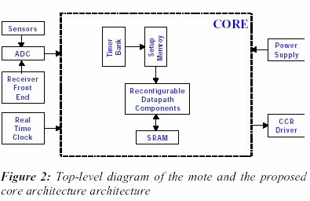

The next figure details a section of the timer bank and setup memory. The timer is loaded from the timer value memory, setting its period. When the timer expires, it enables *setup memory 1,* which configures the data path to perform the desired function. When the data path has finished operation, *setup memory1* will release its configuration and either the timer value can be loaded into the timer and the countdown restarted or *setup memory 2* can be enabled.

*Setup memory 2* will then configure the data path for another operation, thus facilitating multiple operations per timer event. Additional setup memory can be added for more involved sequence. Memory holds certain timer-independent configuration bits, such as timer enables. The sensors registers are used to store previous sensor readings to use in computing data changes. Various computation blocks can be included in the data path, such as an adder, comparator, and FFT unit.

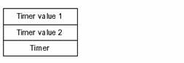

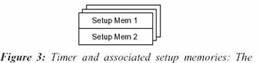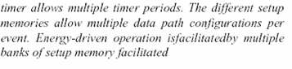

Multiple timer periods are desirable for several situations. For example, one might want to sample a sensor at a slow rate until an interesting signal is detected. At that point, the sampling rate should increase. In addition, the motes might be deployed without anyone coming back to talk to them for a day, so it would be desirable to be able to set the receiver wake-up timer to not wake-up for 24 hours, but then it should decrease the period dramatically to 10’s seconds in case one doesn’t make it back to talk to the mote at exactly the right time. The proposed architecture facilitates this by providing multiple timer values that can be loaded into the timer depending on the results of the data path computation.

Another feature of this architecture is energy-driven operation modes. An energy- monitoring unit selects between multiple banks of setup memory and timer values depending on the current level of the energy stores. Each bank can have different timer periods and algorithms to control energy expenditure. Two types of packets can be sent to the mote, corresponding to the two types of operations. Immediate mode operations use the packet body to configure the data path right away. Reconfiguration operations load the packet body into the setup memory for future configuration.

The following figure shows the functional block included in the reconfigurable data path.

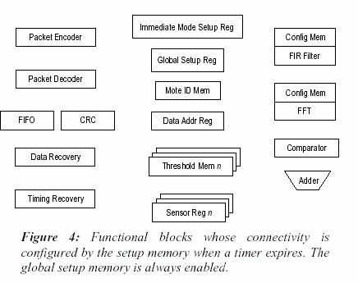

For the communication back end, there is data recovery block, timing recovery block, FIR filter, packet encoder that does bits stuffing and adds the flag byte, packet decoder that does bit unstuffing, CRC block, and a FIFO. Incoming packets are stored in the FIFO until the CRC can be verified, at which point the packet body will be used as described above. The global memory holds certain timer independent configuration bits, such as timer enables. The sensor registers are used to store previous sensor readings to use in computing data changes. Various computation blocks can be included in the data path, such as an adder, comparator, and FFT unit.

All of the functional units in the data path are data driven. The setup memory only powers up and enables the first set of units that are needed, such as sensor and ADC. Once theses units have done their job, they assert a done signal that is routed, based on the configuration memory, to the next unit, such as the adder, and powers it up and enables it. Likewise, when this unit has finished its job, it will power up and enable the next device in the chain. The last unit in the path will cause the timer to reload its value

and cause the setup memory to stop configuring the data path. The advantages of this data driven technique include minimizing the standby power by keeping components powered down until exactly when they are needed, and ensuring that the inputs are stable before the next device is powered up, which minimizes glitches. It is significant to note that since this architecture does not use shared busses as in traditional microcontrollers, the functional components can be configured for certain parallel operations. For example, a sensor reading could be both stored in SRAM and transmitted wit the CCR, although that is not necessarily a desirable capability.

## MAJOR CHALLENGES

1. To incorporate all these functions while maintaining a low power consumption
2. Maximizing operating life given the limited volume of energy storage
3. The functionality can be achieved only if the total power consumption is limited to microwatts level
4. An unbroken line of sight of path should be available for free space optical links.

## APPLICATIONS

1. Civil and military application where chemical and biological agents in a battle field are detected. Smart dust can be used for monitoring activities in inaccessible areas, accompany soldiers and alert them to any poisons or dangerous biological substances in the air.
2. Virtual keyboard: Glue a dust mote on each of your fingernails, accelerometers will sense the orientation and motion of each of your fingertips, and talk to the computer in your watch. Combined with a MEMS augmented-reality heads-up display, your entire computer I/O would be invisible to the people around you.
3. Inventory Control Smart office spaces: The center for the built environment has fabulous plans for the offices of the future in which environmental conditions are tailored to the desires of every individual. Maybe soon we’ll all be wearing temperature, humidity, and environmental comfort sensors sewn into our clothes, continuously talking to our workspaces which will deliver conditions tailored to our needs.
4. Individual dust motes can be attached to the objects one wishes to monitor or a large number of dust motes may be dispersed in the environment randomly.
5. Dust motes may be used in places where wired sensors are unusable or may lead to errors. E.g. Instrumentation of semiconductor processing chambers, wind tunnels, rotating machinery etc.
6. May be used in biological research e.g.: to monitor movements and internal process of insects

## HOW FAR THEY HAVE BEEN IMPLEMENTED

1. The optical receiver for the smart dust project is being developed. The receiver senses incoming laser transmission at up to 1 Mbits/s, for a power consumption of 12µW. Although this is too high for continuous use in smart dust, it is reasonable figure for the download of small amounts of data such as 1 Kbit program.
2. For data transmission, the team is using corner cube retro-reflectors (CCRs) built using MEMS techniques. CCRs are produced by placing three mirrors at right angles to each other to form the corner of a box that has been silvered inside. The key property of a CCR is that light entering is reflected back along the path it is entered on. For the smart dust system, the CCR is being built on a MEMS process with the two vertical sides being assembled by hand. When a light shone into the CCR, it reflects back to the sending position. By modulating the position of one of the mirrors, the reflected beam can be modulated, producing a low energy passive transmission.
3. The analog-digital converter (ADC) the 8 bit ADC has so far demonstrated with an input range of 1 V, equal to the power supply, and a 70 kHz sampling rate. The converter draws 1.8 µW when sampling at that rate, or 27pJ for an 8 bit sample.
4. The latest smart dust mote, with a volume of just 16mm3, has been tested. It takes samples from a photo-detector, transmits their values with the CCR and runs off solar cells.

## SUMMARY

Smart dust is made up of thousands of sand-grain-sized sensors that can measure ambient light and temperature. Each one of the sensors is called “motes” and they have wireless communication devices attached to them and if you put a bunch of them near each other, they’ll network themselves automatically.

These sensors which would cost pennies each if mass-produced, could be plastered all over office building and homes. Each room in an office building might have hundreds or even thousands light and temperature sensing motes, all of which would tie into a central computer that regulates energy usage in the building.

Taken together, the motes would constitute a huge sensor network of smart dust, a network that would give engineers insight into how energy is used and how it is conserved. In a dust-enabled building, computers would turn off lights and climate control in empty rooms. During peak energy usage times, air conditioners that cool servers, which drain a lot of tech world’s power, would be automatically shut off, and then turned on if the server gets too hot. Thus it can very lead to world’s energy conservation solutions.

## REFERENCE

1. P.B. Chu, KSJ Pister- “Optical communication using micro corner cube reflectors” 10th IEEE Int’l Workshop on Micro Electro Mechanical Systems
2. J. Kahn, R.H.Katz, KSJ Pister- “Mobile Networking for Smart Dust”
3. [www.eecs.bekerly.com](http://www.eecs.bekerly.com/)